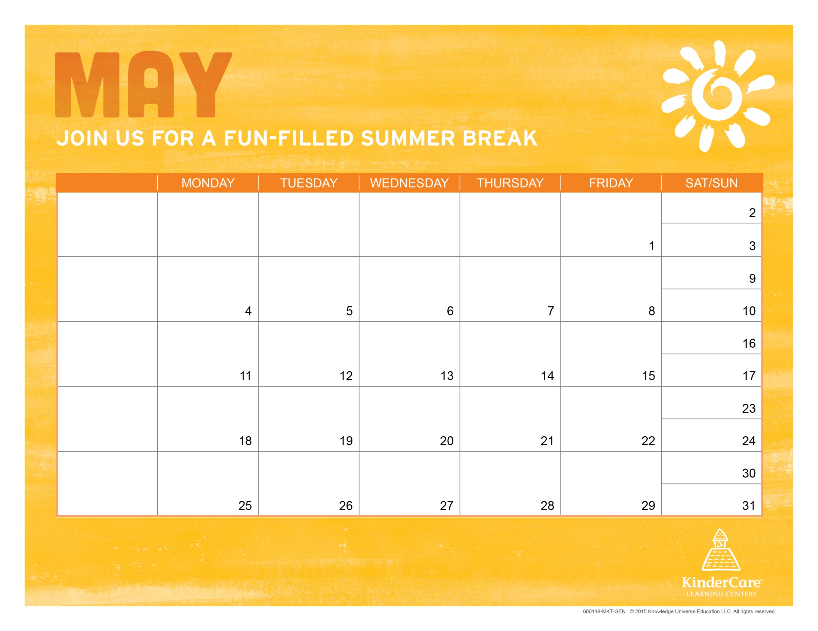

Insert theme |  |  |  |  | Enter text
 | Enter text | Enter text | Enter text | Enter text | Enter text
 | CENTER CLOSED
SCHOOL-AGE SUMMER PROGRAM
Center Director Name
Center Address
Center Phone
Center Email
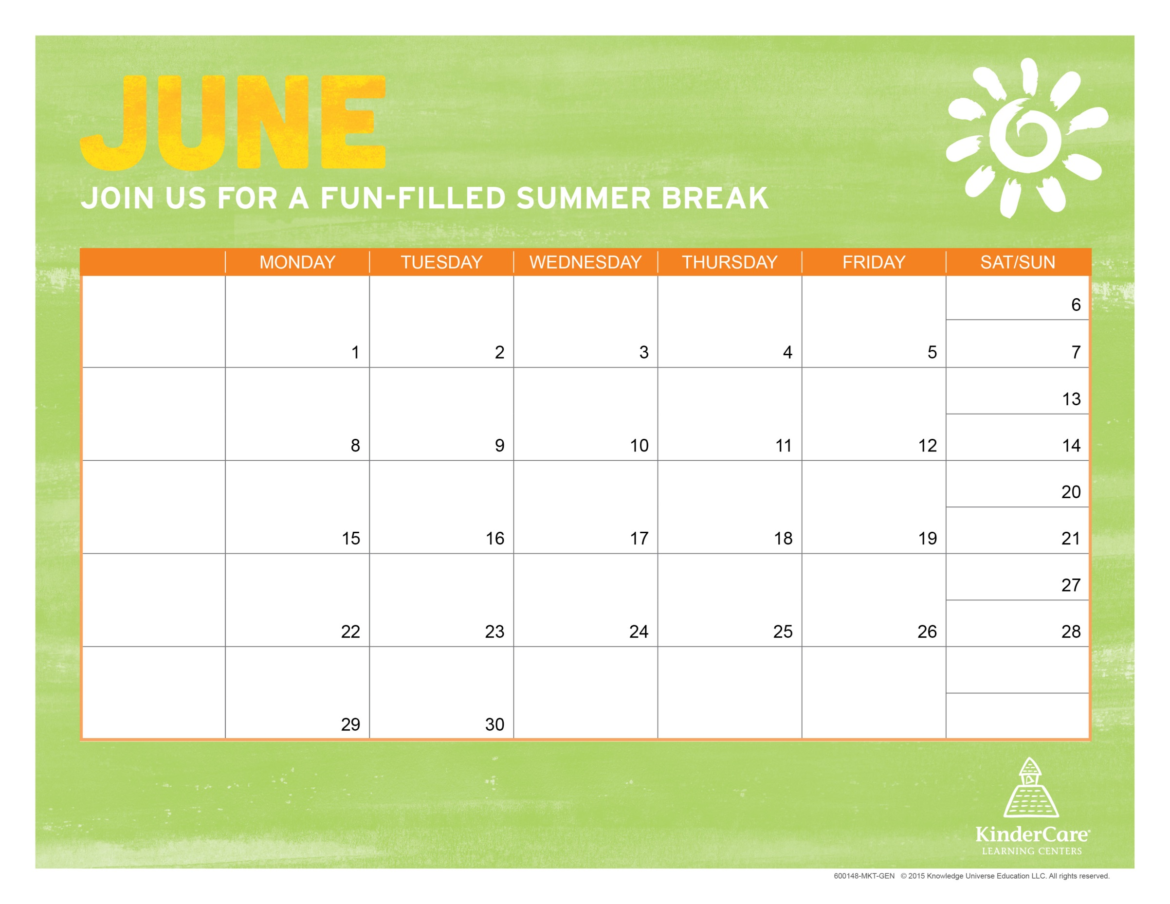

 |  |  |  | School’s out for summer!! | Summer Kick-off Party!
Theme:  Clash of the Colors | Rainbow Ooblek | In-house:  ATA Kick Class  10:00 am | In-house:  Kona Ice  3:30 pm | In-house:  Let ‘Em Eat Cake  3:00 pm | WATER PLAY DAY!  Squirt Gun Art
Theme:  Clash of the Colors | Edible Playdoh | Field trip:  Tides Game  12:00 pm
SCHOOL-AGE SUMMER PROGRAM
Rachel DeCarlo
2205 Poplar Point Rd
757-481-6048
300107@klcorp.com
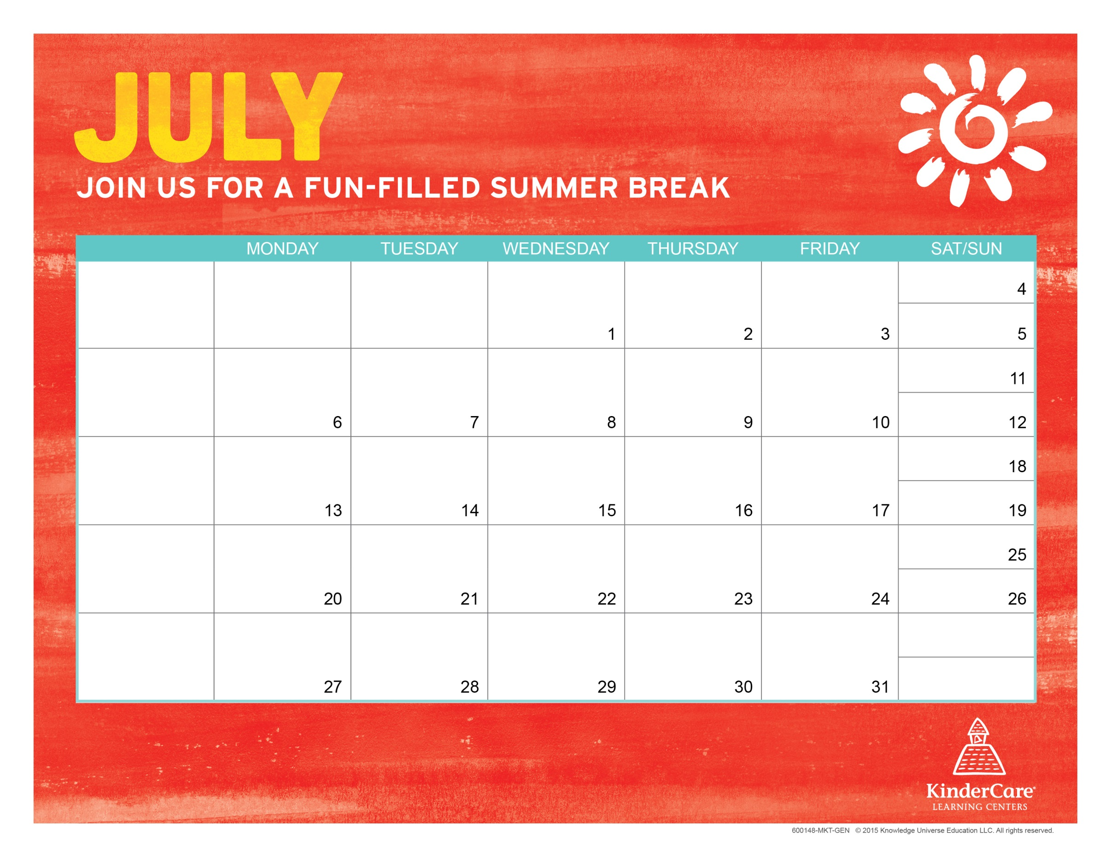

 |  |  |  |  |  | In-house:  Virginia Beach SPCA Critter Visit! 9:30am |  |  | Field Trip:  Mt Trashmore  9:30 am |  |  | CENTER CLOSED  to observe Independence Day
Theme:  Jungles & Rainforests | Field trip:  Farmer’s Market  10:00 am |  | WATER PLAY DAY!  Monkey Bread |  |  | In-house:  Twisted Sisters Cupcake Truck  10:00 am |  |  | Field trip:  Putt-Putt @ Lynnhaven Golf  9:30 am |  |  | In-house:  Via Goode Storyteller  9:00 am
Theme:  Jungles & Rainforests | Rainforest Ants On A Log Snack! |  | Field trip:  Virginia Zoo  10:00 am |  |  | In-house:  The Klumsy Moose  2:30 pm  Virginia Beach Public Library 9am |  |  | Field trip:  Pin Boys 9:30 am |  |  | WATER PLAY DAY!  Jungle Animal Sock Puppets
Theme:  Puzzling Puzzles | Puzzle Piece Cookies |  | Field trip:  Regal Cinema  10:00 am |  |  | In-house:  Riz the Magician  2:00 pm |  |  | Field trip:  Redwing Park  9:00 am |  |  | WATER PLAY DAY!  Make Your Own Face Puzzle
Theme:  Puzzling Puzzles | The Human Knot Game |  | Field trip:  Uno’s Pizzeria  10:00 am |  |  | In-house:  Color Me Mine  2:30 pm |  |  | Field trip:  Laser Quest  10:45 am |  |  | WATER PLAY DAY!
SCHOOL-AGE SUMMER PROGRAM
Rachel DeCarlo
2205 Poplar Point Rd
757-481-6048
300107@klcorp.com
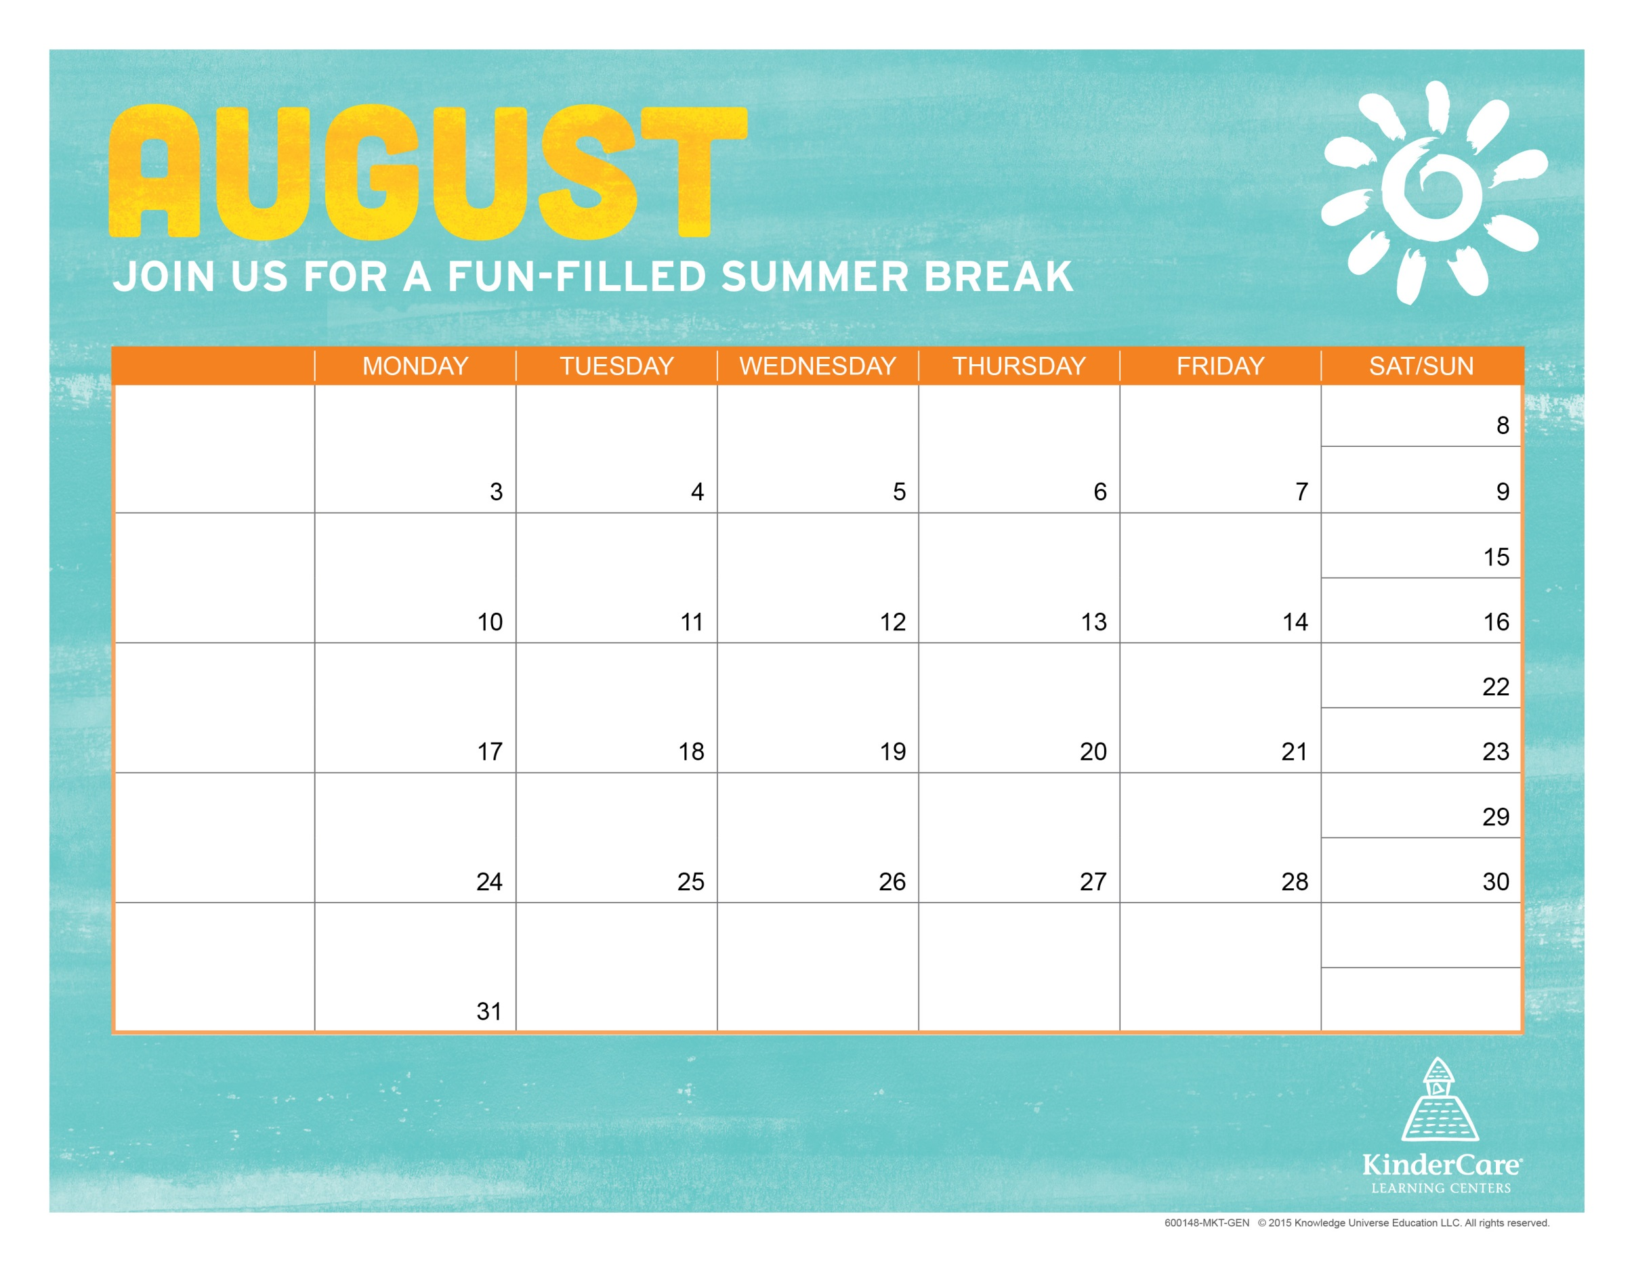

Theme:  Mixed Up Fairy Tales |  | Make A Magic Wand |  | Field trip:  Krispy Kreme  9:30 am |  |  | In-house:  JB’s Rattles  3:30 pm |  |  | Field trip:  Sports Hall of Fame  10:00 am |  |  | WATER PLAY DAY!  Fairy Tale Character Dress Up
Theme:  Mixed Up Fairy Tales |  | Make Your Own Potion! |  | Field trip:  VA Living Museum  10:00 am |  |  | In-house:  Ryan the Balloon Guy  3:00 pm |  |  | Field trip:  VBCPS Planetarium  2:00 pm |  |  | WATER PLAY DAY!  Hero Tag!
Theme:  Our School Age Store |  | Baking For The Charity Bake Sale |  | Field trip:  Yankee Candle  10:00 am |  |  | In-house:  Kona Ice  3:30 pm |  |  | Field trip:  Children’s Museum  9:30 am |  |  | WATER PLAY DAY!  Bake Sale Day!
Theme:  Our School Age Store |  | Making The “Dough” Home Made Playdough! |  | Field trip:  Schakolad Chocolate Factory  10:00 am |  |  | In-house:  Kona Ice  3:30 pm |  |  | Field trip:  VA Aquarium  9:00 am |  |  | WATER PLAY DAY!  Make Your Own Currency
Theme:  Super Heroes Among Us |  | Which Super Hero Am I?
SCHOOL-AGE SUMMER PROGRAM
Center Director Name
Center Address
Center Phone
Center Email
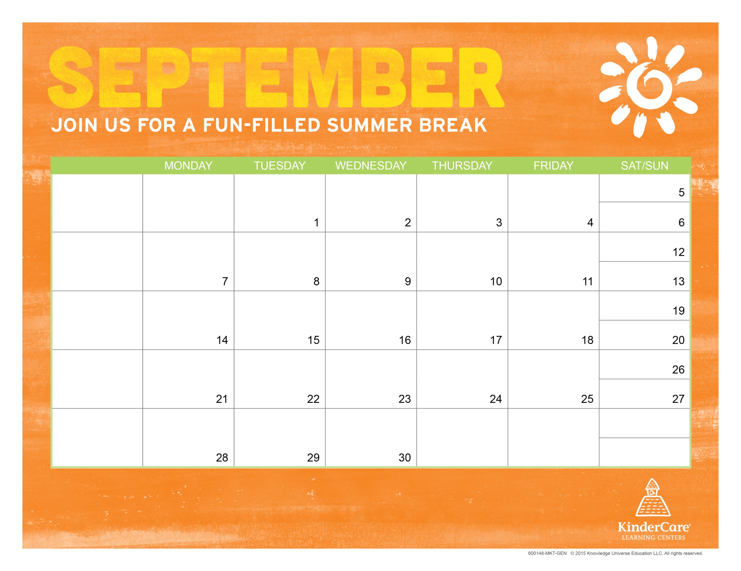

Theme:  Super Heroes Among Us |  |  |  | In-house:  Buckets the Safety Clown & Fire Truck  10:00 am |  |  | WATER PLAY DAY! |  |  | In-house:  Smokey the Bear  9:00 am |  |  | End of Summer Party with Astro DJ!  3:00 pm
 |  | CENTER CLOSED FOR LABOR DAY
SCHOOL-AGE SUMMER PROGRAM
Center Director Name
Center Address
Center Phone
Center Email

